EmbedUr module 4 assignments – linux and bash scripting
- Logical operators
Check whether the file exists and is executable using logical operators. Hint :man test
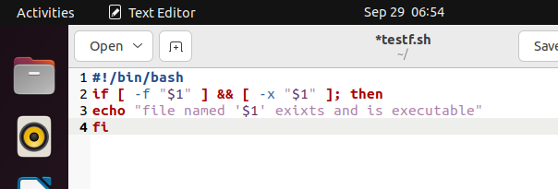
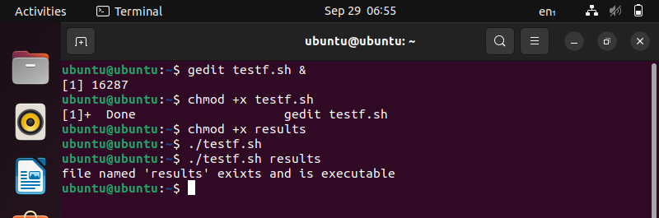
- Arithmetic comparison
Write a program to demonstrate the use of not equal to operator. Hint: -ne
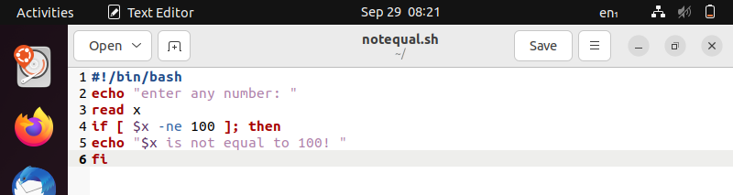
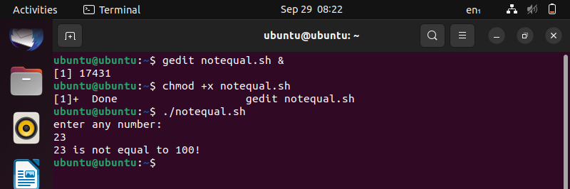
- String and file attributes
Explore some more attributes -r -x -o
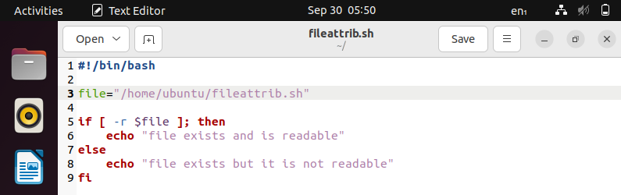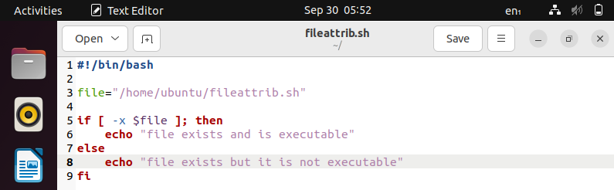
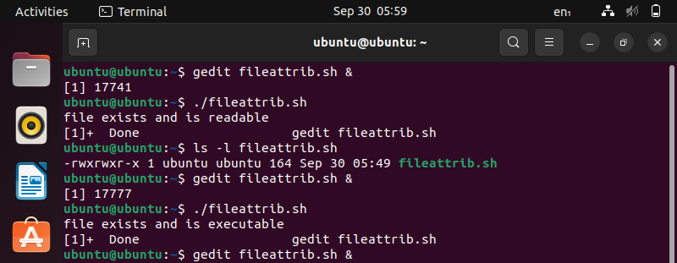

- Conditional loops
Find the sum of first n prime numbers.
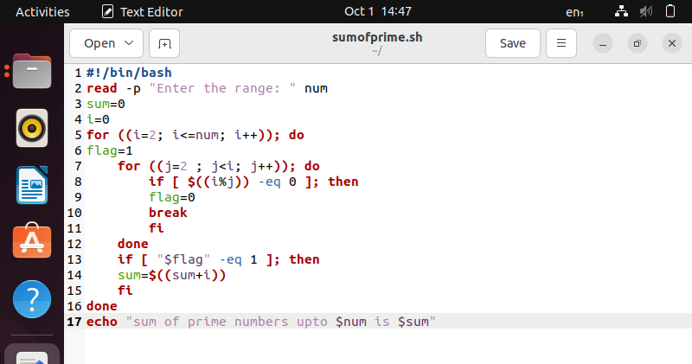
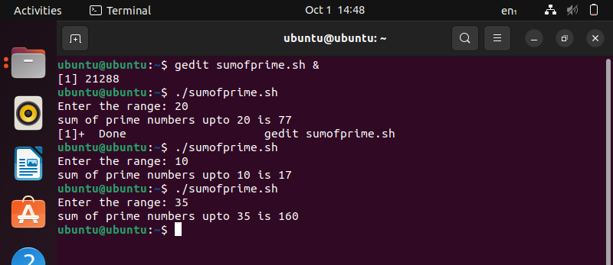

- More on loops
1) Retype nested-for.sh bash script using nested while loop
2) Save your program with the name: nested-while.sh
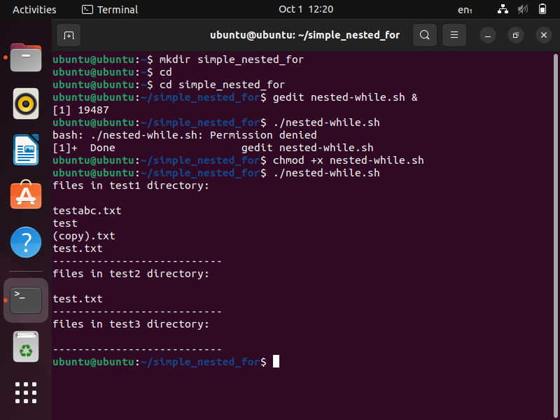
- Case statement
Write a menu driven program for mathematical calculation
a. It should take user inputs a and b
b. It should ask for mathematical operator (+, -, / and *).
c. Do the calculation
d. Print the output
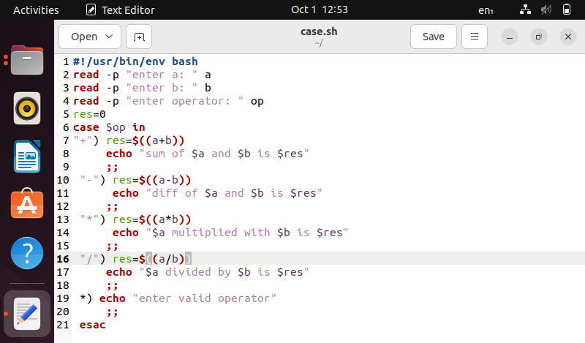
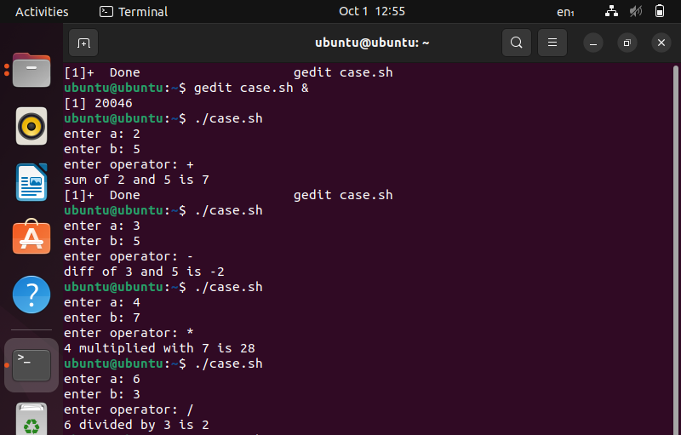
- Using file descriptors
- Try to append few lines to a file test.txt using file descriptor. 2) Display the content of the file using file descriptor
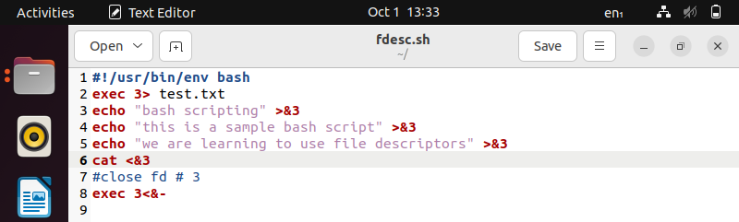
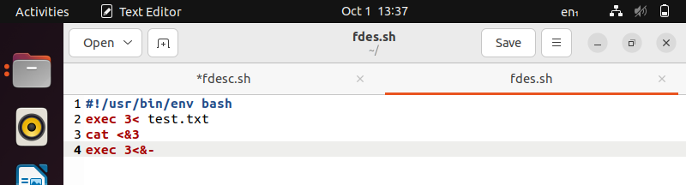
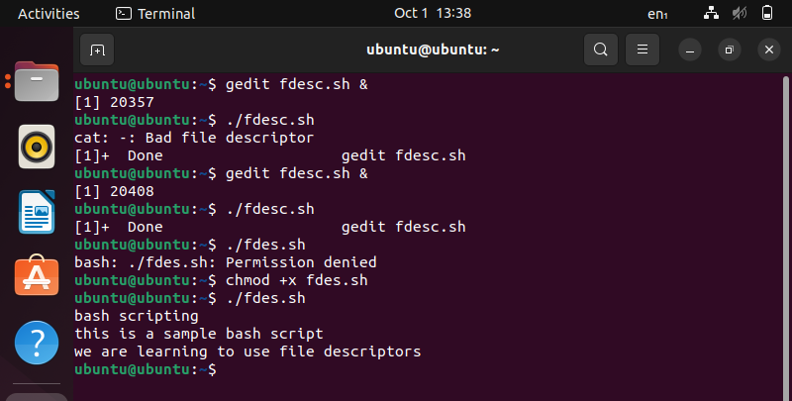
- Basics of functions
Write a program with two functions:
a. The first function should display diskspace usage in human readable form.
(Hint: df -h)
b. The second function should display filesystem usage in human readable form.
(Hint: du -h)
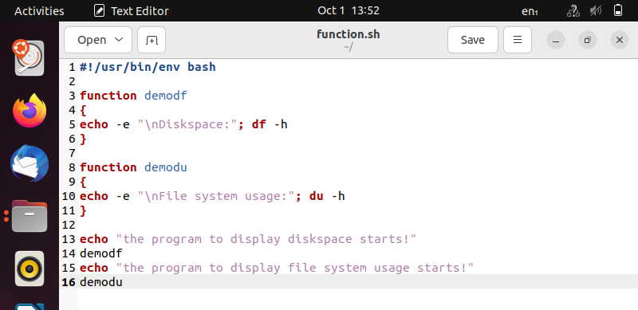
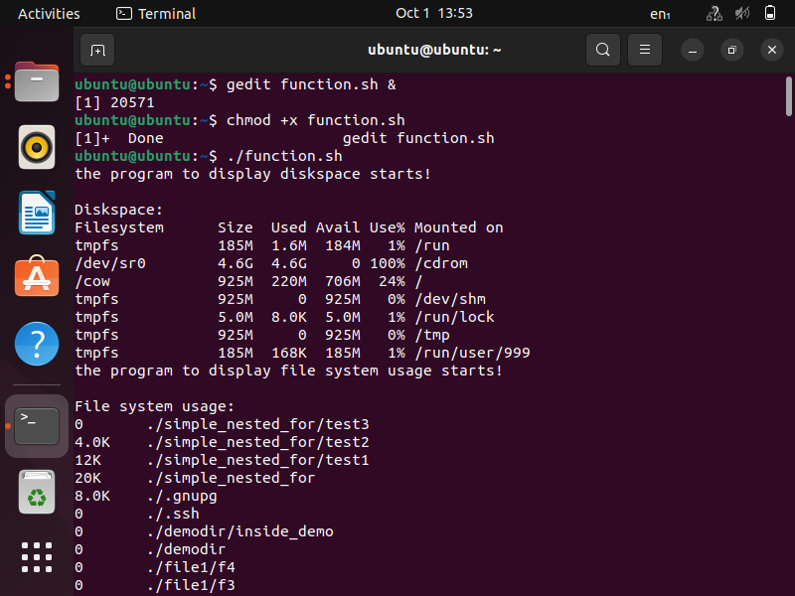
- More on functions
Write a program,
a. where the function accepts two arguments.
b. The function should multiply the two arguments.
c. Make 3 function calls with arguments - (1, 2), (2, 3) and (3, 4)
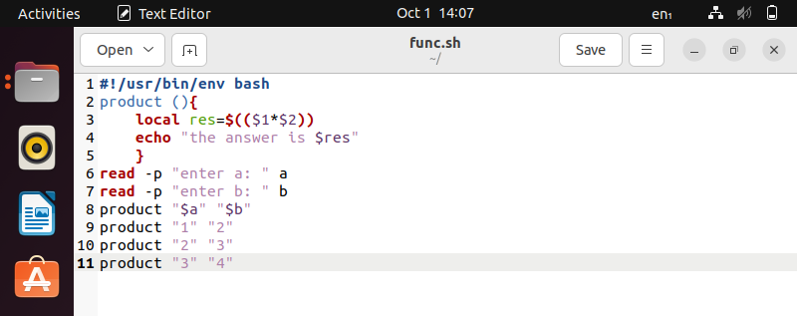
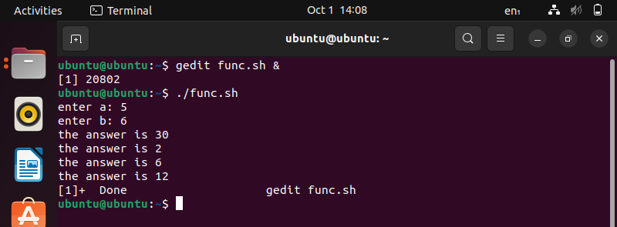
- Arrays and functions
Write a program,
a. Where a function adds all the elements in an array.
b. The function should display the sum of elements.
c. Make 2 function calls with array elements- (1, 2, 3) and (4, 5, 6).
